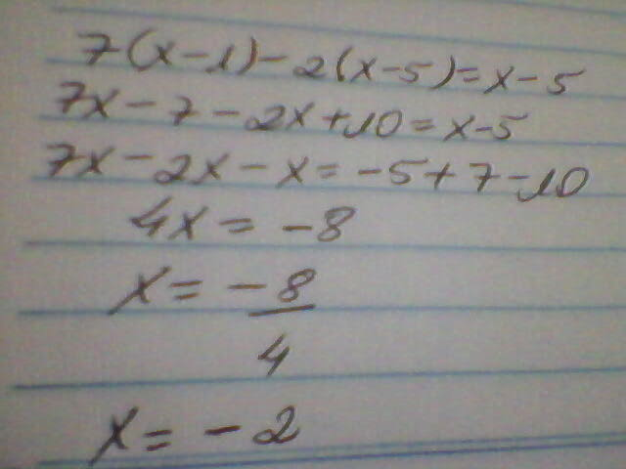

2(3 - x ) = 3 (x - 4 ) + 15
6-2x=3x-12+15
6+12-15=3x+2x
3=5x
X=3/5
3(5 - x ) - 3 (1 - 2x ) = 44
15-3x-3+6x=44
3x=44-15+3
3x=32
X=32/3
X=10,67
(4x + 6 ) - 2x (x - 6) + 10 + 14
(4x+6)-2x²+12x+10+14
4x+6-2x²+12x+10+14
16x+30-2x²
Δ=b²-4.a.c
Δ=16²-4.(-2).30
Δ=256+240
Δ=16

X=-b+-√Δ/2.a
X=-16+-√16/2.(-2)
X=-16+-4/-4

X¹=-16+4/-4
X¹=-12/-4
X¹=3

X²=-16-4/-4
X²=-20/-4
X²=5
(x - 3 ) - (x - 2) + 2 (x - 1) - 5 = 0
x - 3 - x + 2 + 2x - 2 - 5 = 0
2x=3-2+2+5
2x=8
X=8/2
X=4
3x - 2 (4x - 3) = 2(x - 1) - 5 = 0
3x - 8x + 6= 2x - x - 5 = 0
3x - 8x -2x+x= - 5 -6
-6x=-11
X=-11/-6
X=11/6
3x - 2(4x - 3 ) = 2 - 3 (x - 1)
3x - 8x + 6 = 2 - 3x +3
3x-8x+3x=2+3-6
-2x=-1
X=-1/-2
X=1/2
3(x - 1) - (x - 3 ) + 5 (x - 2 ) = 18
3x - 3 - x +3 + 5x - 10 = 18
3x - x +3 + 5x = 18+10+3
10x=31
X=31/10
X=3,1
5(x - 3) - 4(x + ) = 2 = 2 + 3 ( 1 - 2x)
Está faltando.

