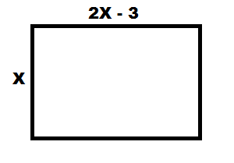
X + X + (2X - 3) + (2X - 3) = 42
2X + 2X – 3 + 2X – 3 = 42
6X – 6 = 42
6X = 48
X = 8

